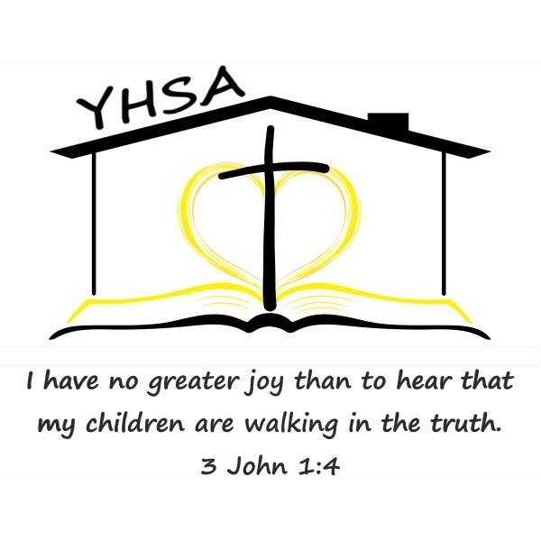
2024 Evaluator Questionnaire

Name: Stephanie Fonticoba Date: February 26, 2024

Are you a current or alumni member of YHSA? YES

- Which of the following are you qualified/approved to do: (Please check all that apply)

X Elementary Evaluations (beginner through grade 6)
X Secondary Evaluations (grades 7 through 12)
    - Approval of Objectives for special needs students

- Under which of the following do you evaluate in Pennsylvania? (Please check all that apply.)

- Licensed clinical or school psychologist.

X Teacher certified by the Commonwealth with at least two years of experience at the elementary level (through grade 6) grading any of the following subjects: English, to include spelling, reading, and writing; arithmetic; science; geography; history of the United States and Pennsylvania; and civics.

- Teacher certified by the Commonwealth with at least two years of experience at the secondary level (grades 7-12) grading any of the following subjects: English, to include language, literature, speech, reading and composition; science, to include biology, chemistry and physics; geography; social studies, to include economics, civics, world history, history of the United States and Pennsylvania; foreign language; and mathematics, to include general mathematics, algebra, trigonometry, calculus and geometry.

- Nonpublic school teacher or administrator with at least two years of teaching experience at the elementary level within the last 10 years (grading any of the following subjects: English, to include spelling, reading and writing; arithmetic; science; geography; history of the United States and Pennsylvania; and civics) in a Pennsylvania public or nonpublic school.

X Nonpublic school teacher or administrator with at least two years of teaching experience at the secondary level within the last 10 years (grading any of the following subjects: English, to include language, literature, speech, reading and composition; science, to include biology, chemistry and physics; geography; social studies, to include economics, civics, world history, history of the United States and Pennsylvania; foreign language; and mathematics, to include general mathematics, algebra, trigonometry, calculus and geometry) in a Pennsylvania public or nonpublic school.

- Other qualifications with the prior consent of the district superintendent.
(Answer questions below only if you evaluate under this option):

Please give a brief summary of your qualifications:

Please list the districts which have given consent for you to perform evaluations under “other qualifications”:
- Do you currently or have you ever educated your own children/grandchildren at home?

YES, under Private Tutor option

If yes, what ages of children or number of years? Since 2003, Ten children
Ages: Born from 1999 through 2013
Grades: Elementary through High School

- How long have you been conducting home education program evaluations?
I have been conducting home education program evaluations since 1999.

- What is your educational philosophy?
My educational philosophy is that parents are their child's first and best teachers. I believe that parents have the right to choose the educational program that best fits their family's needs. Each child is a unique individual whose educational needs can be met in various ways.

- What types of home education programs do you have experience evaluating? (Circle all that apply)
I have experience evaluating with all five programs:

Traditional School at Home, Relaxed/Eclectic, Unschooling, Classical Conversations, & Charlotte Mason

- Where/how do you conduct evaluations: Circle all that apply.
I am willing to perform the evaluations: At my home, and also via Phone, Video chat/Zoom, and Email

- The PA Home Education Law states an “annual written evaluation of a student’s academic progress…. shall also be based on an interview of the child and a review of the portfolio...and shall certify whether or not an appropriate education is occurring.” Portfolio is defined as “a log, made contemporaneously with the instruction, which designates by title the reading materials used, samples of any writings, worksheets, workbooks or creative materials used or developed by the student and in grades three, five and eight results of nationally-normed standardized achievement tests in reading/language arts and mathematics or the results of Statewide tests administered in these grade levels.” Appropriate education is defined as, “a program consisting of instruction in the required subjects for the time required in this act and in which the student demonstrates sustained progress in the overall program.”

What do you require families to provide in their portfolio or interview to demonstrate progress?
I only require parents to show what is required by law, as stated above. Parents are free to choose learning samples from each subject area to include in the portfolio to show that learning has taken place. Usually, 10 samples for each subject are sufficient to compare growth over the course of the year. This may or may not include things like tests, worksheets, projects, photos, journals, field trip brochures, etc.

- What is your religious affiliation, if any? Christian/Roman Catholic

- What is your fee for evaluations?
$40 per evaluation.

- If qualified, what is your fee for special needs objectives approval? N/A

- Do you have references available upon request? YES

References available upon request.

As a teacher certified by the Commonwealth, I can perform evaluations in any district throughout the Commonwealth of Pennsylvania.

- Please indicate your preferred method of contact:

Stephanie Fonticoba
Cell: 717-715-7179 I can receive texts.
Email: fonticoba@hotmail.com

